Comparison:

|  |  |  |
| --- | --- | --- |
| Source type | Explain plan- Statistics | Time, sec |
| Advanced Grouping |  | 11 |
| Model Clause | See below | 138 |
| Star Schema |  | 2 |

Model Clause Explain plan

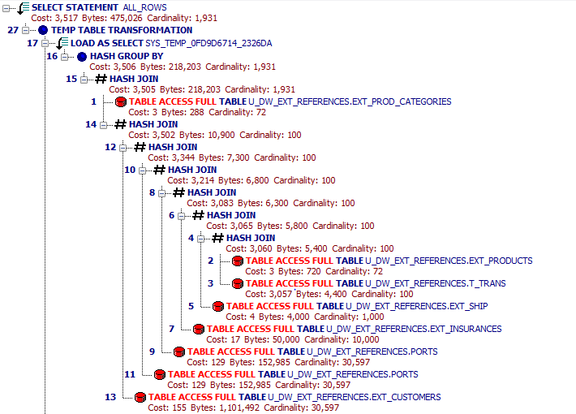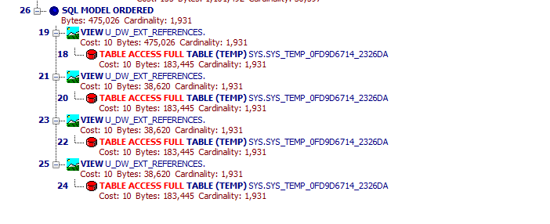

Advanced grouping:

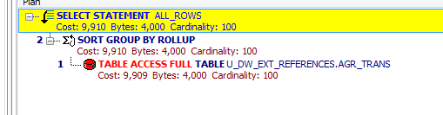

Star schema:

*/* Formatted on 8/12/2013 10:52:47 PM (QP5 v5.139.911.3011) */*

SELECT DECODE ( GROUPING ( event_dt ), 1, 'GRAND TOTAL', event_dt )

, DECODE ( GROUPING ( company_name ), 1, 'ALL COMPANIES', company_name )

, ROUND ( AVG ( pct_goods )

, 2 )

, SUM ( income )

, COUNT ( amount_tot )

FROM fct_trans_monthly fct JOIN dim_customers cust ON fct.company_id = cust.customer_id

WHERE TRUNC ( fct.event_dt

, 'MM' ) = '1-JAN-2013'

GROUP BY ROLLUP ( fct.event_dt, cust.company_name )

ORDER BY 1;

